WP3 – Machine Learning experiments
Report on machine learning experiments using (existing) datasets for reading comprehension – GitHub repository: Tsiakas-OU/eyeteach-ML

- MECO-L1
- Description: Participants read one passage (1-12) and answer 4 questions.
- Version: release 2.0/version 2.0/wave 2
- Language: en_uk

  - Passage-level data – each line corresponds to a participant reading one passage (participants read multiple passages)
File: eyeteach-ML/datasets/mecoL1/MECO-en_uk-passage.csv
Features: 'trial.nwords', 'nblink', 'nrun', 'nfix', 'nout', 'sac', 'skip', 'refix', 'reg', 'mfix', 'firstpass',
'rereading', 'total', 'rate', 'flesch_readability', 'ACCURACY' – check for more

    - Trial-based data exploration
Treating each trial separately – each feature vector includes the data from one participant reading one passage (1-12). ACCURACY is the number of correct responses [0-4] for this trial.

Dataset Overview:
• Total observations: 481
• Total features: 16
• Participants: 50
• Passages: 12

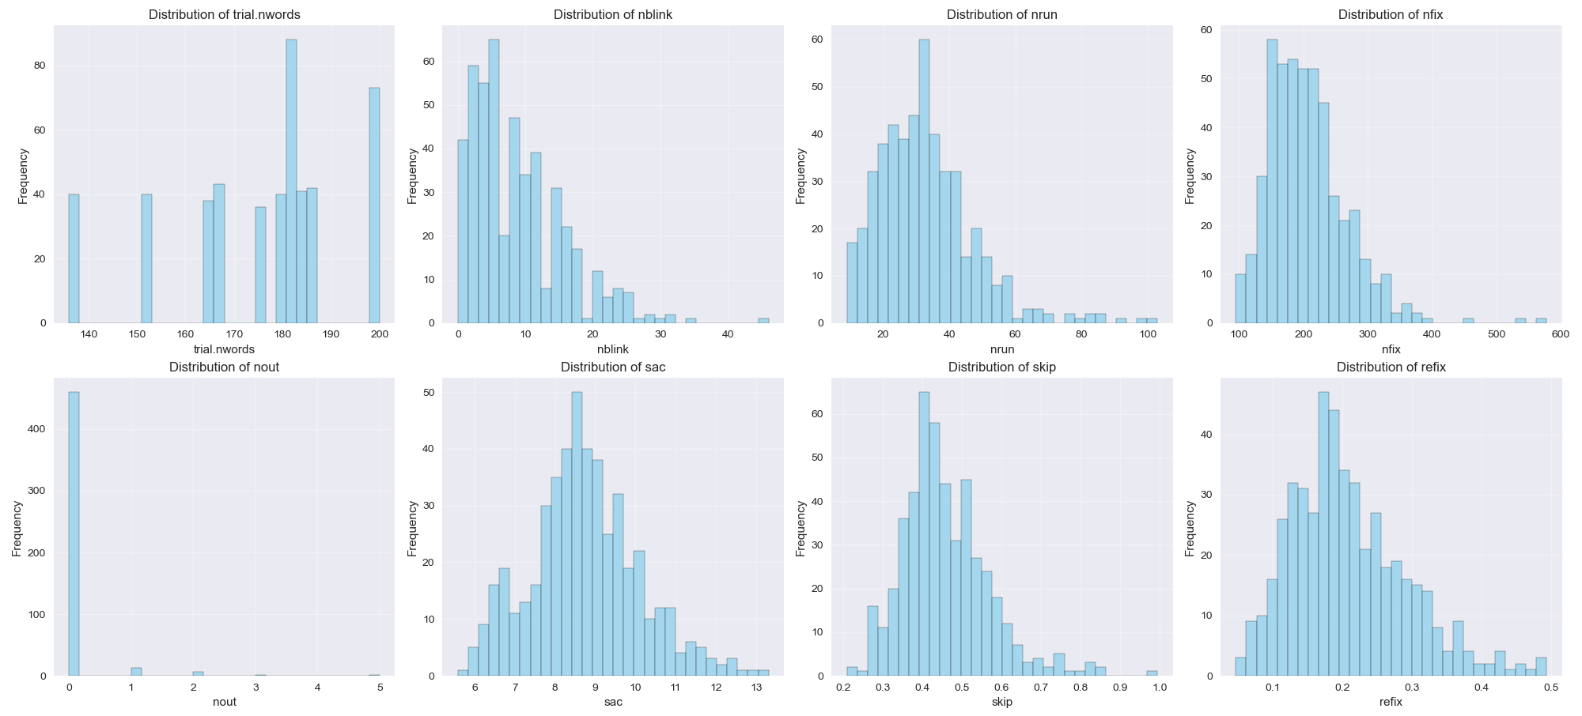
Feature distributions

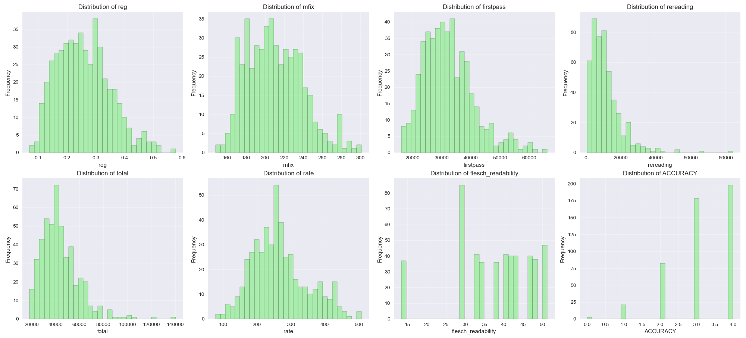

Correlations

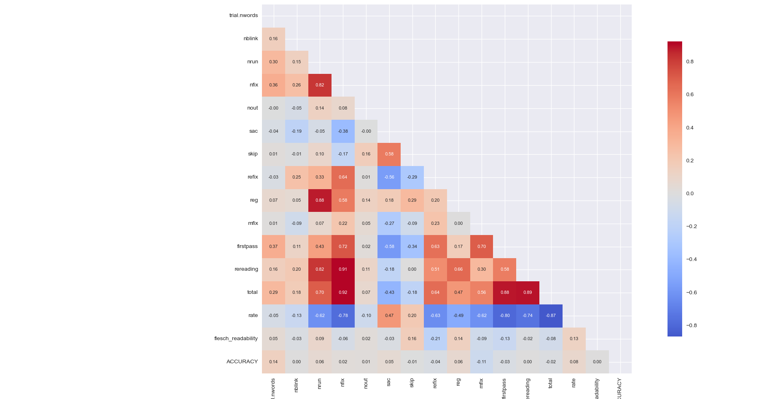
High correlations:

nfix: total, firstpass, rate, rereading, nrun

rereading: nrun, nfix, rate

reg: nrun

mfix: firstpass

total: nrun, firstpass, nfix, rereading, rate

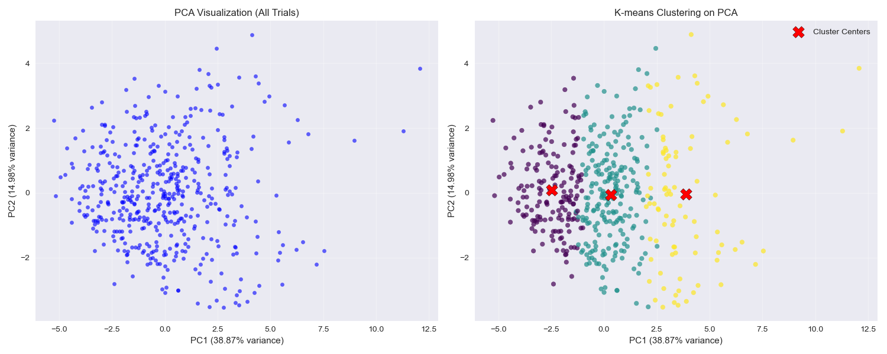
PCA and clustering analysis

Explained variance by first 5 components:
PC1: 0.389 (38.9%)
PC2: 0.150 (15.0%) 53.9%
PC3: 0.085 (8.5%)
PC4: 0.071 (7.1%)
PC5: 0.064 (6.4%)

Cluster distribution:
Cluster 0: 168 samples (34.9%)
Cluster 1: 225 samples (46.8%)
Cluster 2: 88 samples (18.3%)

Top features contributing to PC1
total: 0.392
nfix: 0.379
rate: 0.365
rereading: 0.352
firstpass: 0.344

High PC1 values indicate longer total time, more fixations, more rereading, extensive first-pass reading and slower reading pace, probably indicating more effortful reading. Low PC1 values indicate shorter time, fewer fixations, less rereading, and faster reading, probably indicating less effortful reading.
- PC1 could describe reading effort – from effortful/thorough to efficient/skimming reading

Top features contributing to PC2:
reg: 0.465
skip: 0.447
sac: 0.423
nrun: 0.364
mfix: 0.230

High PC2 values mean more regressions, more saccades, more reading runs and more fixations, probably indicating more careful reading. Low PC2 values mean fewer regressions, fewer saccades and fewer fixations, probably indicating more “routine” reading.
- PC2 could describe reading pattern – from controlled to more automatic reading

Features most correlated with cluster assignments (correlation values):
total: 0.849
rate: 0.841
nfix: 0.821
firstpass: 0.786
rereading: 0.723

Features with significantly different means across the clusters (ANOVA F-value):
feature | f-value | p-value (p << 0.05)
total | 670.25 | 2e-139
rate | 596.22 | 1e-130
nfix | 537.15 | 5e-123
firstpass | 388.92 | 5e-101
rereading | 300.15 | 3e-85

Note: This approach treats each trial (participant reading one of the texts) as independent
    - Trial-based classification – ACCURACY prediction
Target: Merged ACCURACY to ACCURACY_CLASS – 3 classes:
- Perfect (4) 198 samples
- High (3) 178 samples
- Low-Medium (0,1,2) 105 samples (0: 2, 1: 21, 2: 82)

Random Forest - Leave-One-Passage-Out Cross Validation (test on new passage)
- Use trial data from P-1 passages for training data
- Apply SMOTE for balancing dataset
- Estimate feature importances and select K = 5 top features

Classification Report
 | Precision | recall | F1-score | support
Low-Medium | 0.19 | 0.36 | 0.25 | 105
High | 0.39 | 0.33 | 0.36 | 178
Perfect | 0.51 | 0.33 | 0.4 | 198
Accuracy |  |  | 0.34
Macro avg | 0.36 | 0.34 | 0.34
Weighter avg | 0.4 | 0.34 | 0.35

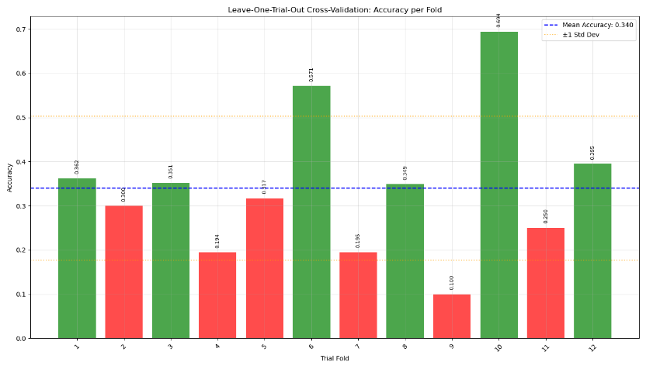

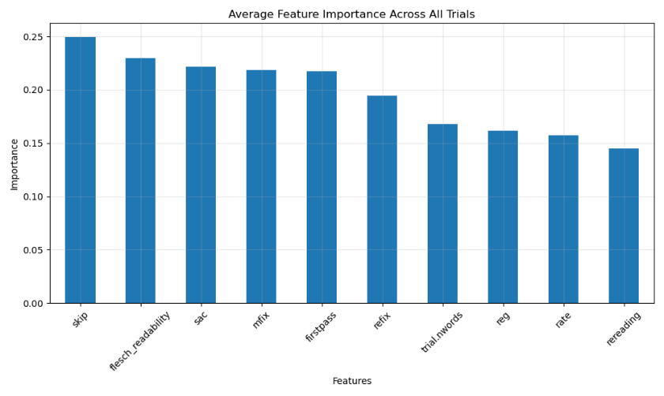
    - Participant-based data exploration
Aggregate participant data from all trials/passages. A participant feature vector is defined based on the mean values of the features from all trials of each participant.

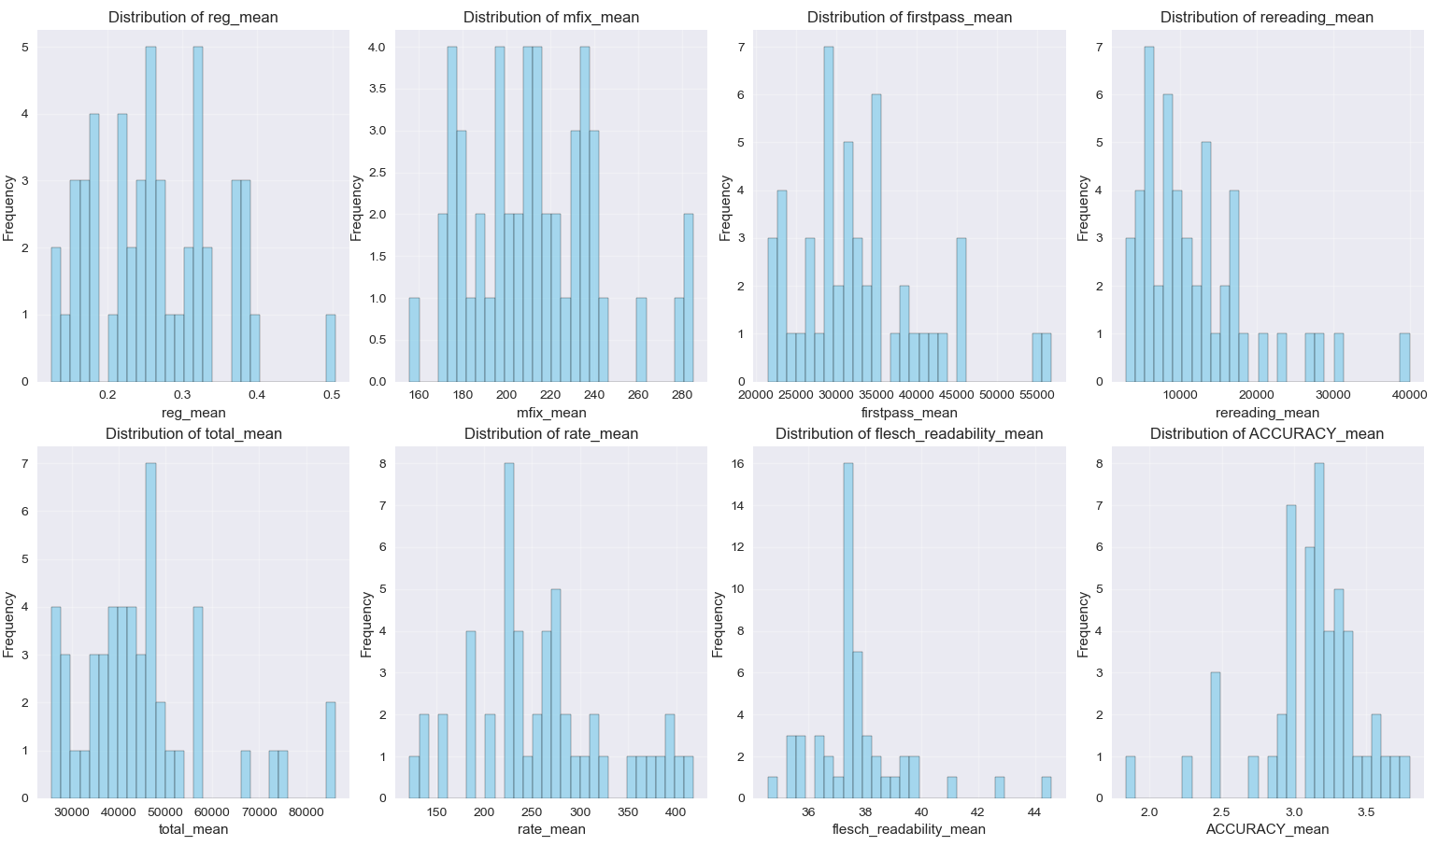
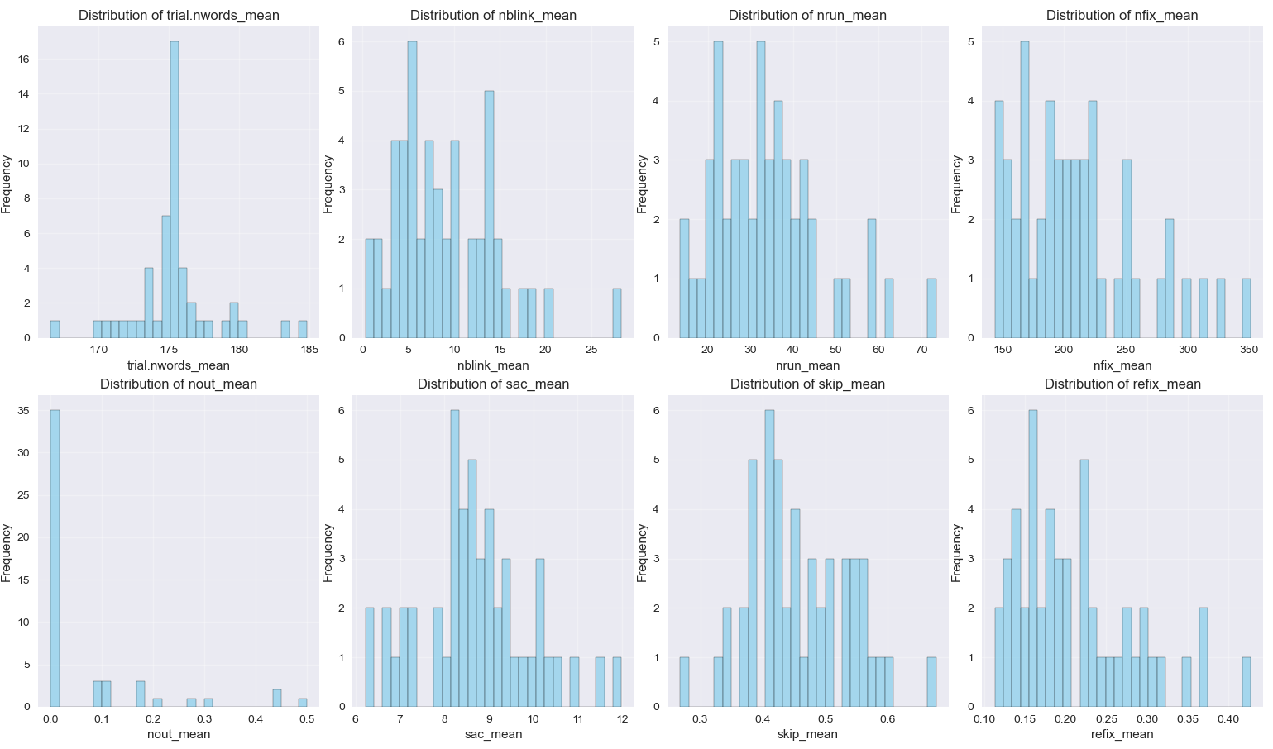
Feature Distributions (means of feature values per participant)
Participant consistency (average std across features):
- Most consistent participant: en_uk_30 (454.022)
- Least consistent participant: en_uk_50 (4333.571)

Participant Consistency – average std of all participants
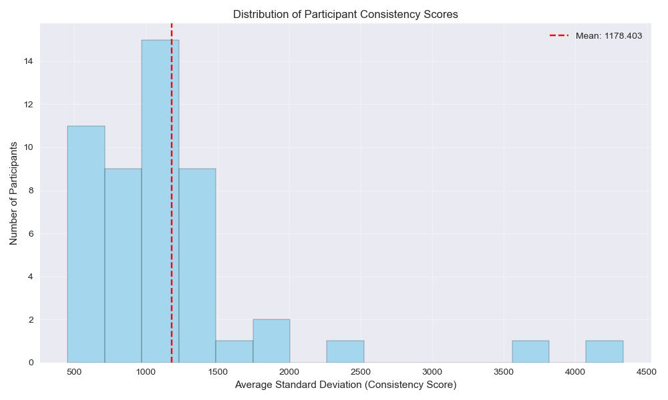

Feature Correlations
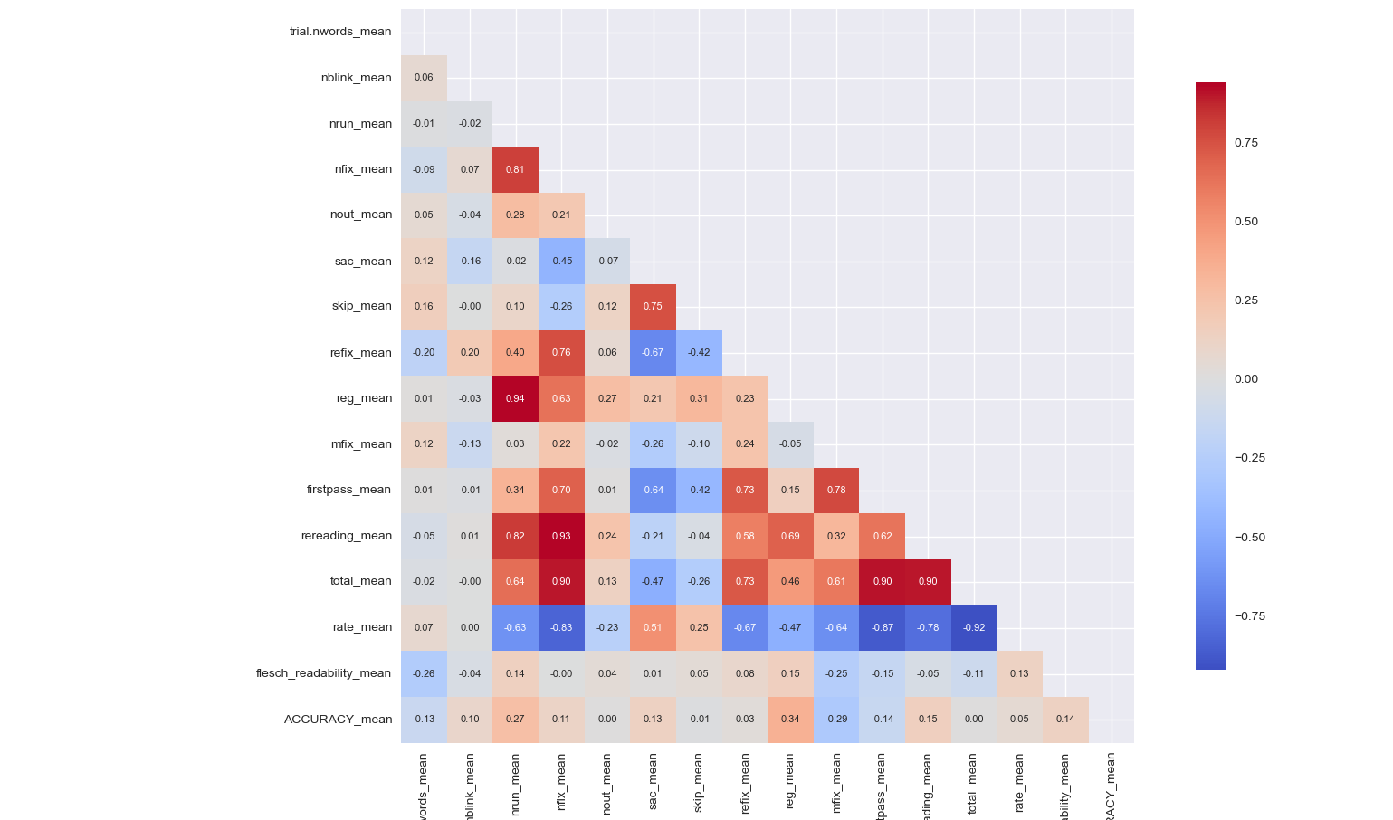

Strong correlations:
- total: nfix, firstpass, rereading
- nfix: nrun, rate, total, rereading, refix
- rereading: nrun, nfix
- reg: nrun
- skip: sac

PCA and clustering analysis
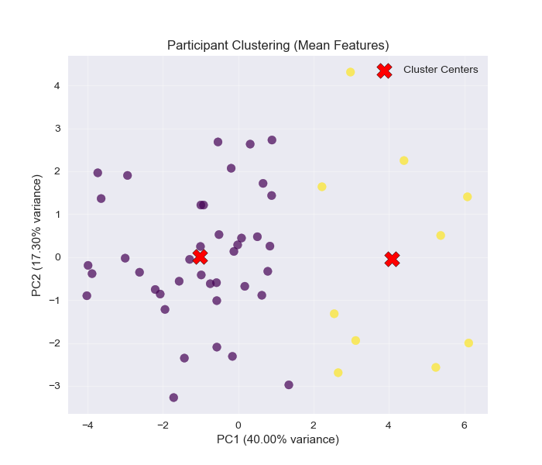
Explained variance by first 5 components:
PC1: 0.400 (40.0%)
PC2: 0.173 (17.3%) 57.3%
PC3: 0.110 (11.0%)
PC4: 0.072 (7.2%)
PC5: 0.062 (6.2%)

Participant cluster distribution:
Cluster 0: 40 participants (80.0%)
Cluster 1: 10 participants (20.0%)

Average consistency (std) by cluster:
Cluster 0: 1007.762
Cluster 1: 1860.965

Top features contributing to PC1 (same with trial-based feature vectors):
total_mean: 0.385
nfix_mean: 0.374
rate_mean: 0.373
rereading_mean: 0.351
firstpass_mean: 0.343
Top features contributing to PC2:
reg_mean: 0.475
sac_mean: 0.385
nrun_mean: 0.383
skip_mean: 0.382
ACCURACY_mean: 0.275

High PC1 values mean longer total time, more fixations, more rereading, extensive first pass reading and slower reading pace, probably indicating more effortful reading. Low PC1 values mean shorter time, fewer fixations, less rereading, and faster reading, probably indicating less effortful reading.
- PC1 could describe reading effort – from effortful/thorough to efficient/skimming reading

High PC2 values mean more regressions, longer saccades, more runs, more skipping, and higher accuracy, probably suggesting more strategic/exploratory reading. Low PC2 values mean fewer regressions, shorter saccades, fewer runs, less skipping, and lower accuracy, probably suggesting a more linear reading style.
- PC2 could indicate reading strategy/style – from more strategic/exploratory to more linear reading

Features most correlated with cluster assignments:
total_mean: 0.803
nfix_mean: 0.798
rereading_mean: 0.744
firstpass_mean: 0.703
refix_mean: 0.682

Feature importance for cluster differentiation (ANOVA F-values):
Feature F-value p-value (p << 0.05)
total_mean 87.1815 0.0000
nfix_mean 84.0871 0.0000
rereading_mean 59.5978 0.0000
firstpass_mean 46.8886 0.0000
refix_mean 41.6298 0.0000
rate_mean 37.0805 0.0000
nrun_mean 26.8704 0.0000
sac_mean 12.5471 0.0009
reg_mean 10.5504 0.0021
mfix_mean 5.8620 0.0193
    - Classification with Leave-One-Participant-Out cross validation
- Use trial data from N-1 participants for training data
- Apply SMOTE for balancing dataset
- Estimate feature importances and select K = 5 top features
- Test on trial data from “new” participant

Example output (for one fold):
Fold 7/50: Testing participant en_uk_16
After SMOTE - Train samples: 469 → 579
Selected 5 features: ['trial.nwords', 'mfix', 'firstpass', 'flesch_readability', 'refix']
Feature importances: {'trial.nwords': 0.088, 'mfix': 0.077, 'firstpass': 0.076, 'flesch_readability': 0.075, 'refix': 0.075, 'rate': 0.072, 'rereading': 0.072, 'total': 0.07, 'reg': 0.07, 'sac': 0.07, 'skip': 0.069, 'nfix': 0.067, 'nrun': 0.059, 'nblink': 0.057, 'nout': 0.003}
Train samples: 469, Test samples: 12, Features: 5, Accuracy: 0.750

Classification report
 | Precision | recall | F1-score | support
Low-Medium | 0.35 | 0.37 | 0.36 | 105
High | 0.39 | 0.33 | 0.36 | 178
Perfect | 0.58 | 0.65 | 0.61 | 198
Accuracy |  |  | 0.47
Macro avg | 0.44 | 0.45 | 0.44
Weighted avg | 0.46 | 0.47 | 0.46

Confusion Matrix
 | Low-Medium | High | Perfect
Low-Medium | 39 | 35 | 31
High | 57 | 58 | 63
Perfect | 16 | 54 | 128

Average Feature Importance in Final Models:
nfix: 0.2508
flesch_readability: 0.2301
mfix: 0.2268
firstpass: 0.2193
rate: 0.2101
refix: 0.2042
sac: 0.1945
total: 0.1916
skip: 0.1886
reg: 0.1828
rereading: 0.1533
trial.nwords: 0.1521
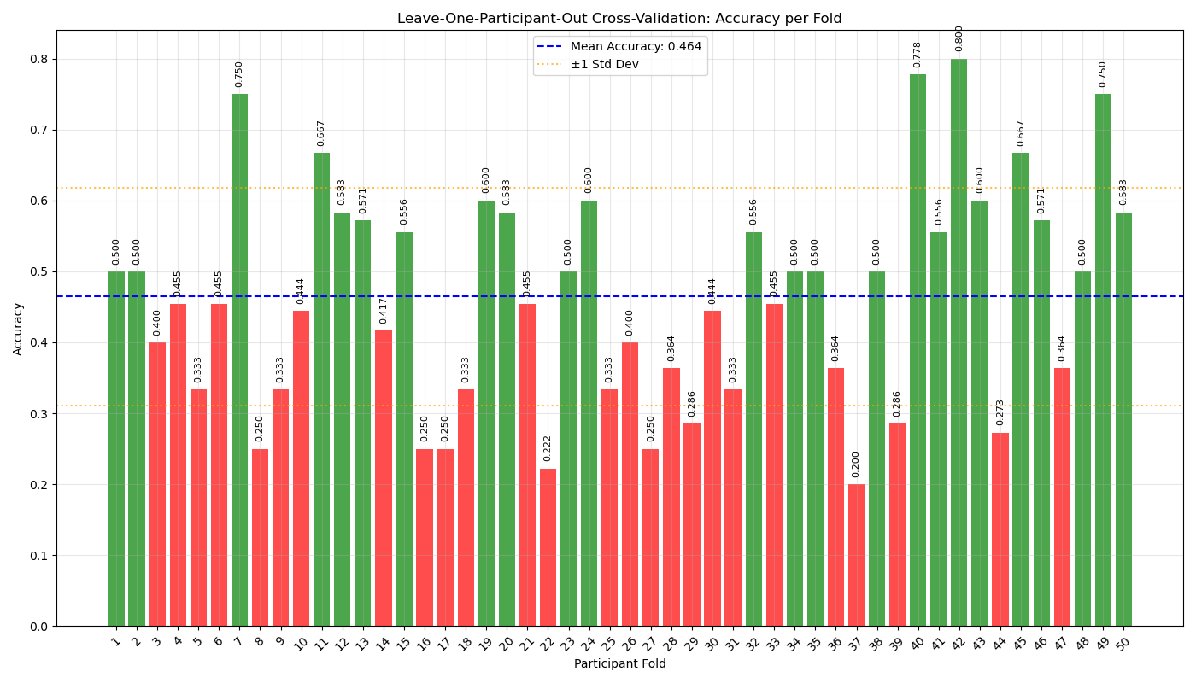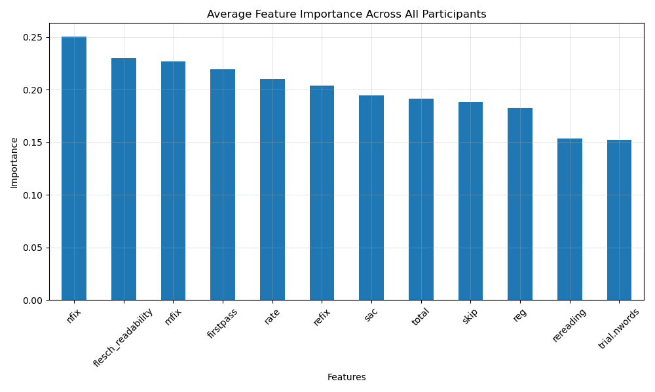

    - Leave-One-Participant-Out Cross-Validation with Cluster-Specific Models

- Cluster participants based on participant-based feature vectors
- For each participant:
  - Train a model using the trial data from the participant’s assigned cluster
  - Test it on the participant’s trial data (multiple trials/passages)

Cluster distribution:
Cluster 0: 40 participants (80.0%)
Cluster 1: 10 participants (20.0%)

Classification report
 | Precision | recall | F1-score | support
Low-Medium | 0.32 | 0.35 | 0.34 | 105
High | 0.44 | 0.38 | 0.41 | 178
Perfect | 0.57 | 0.61 | 0.59 | 198
Accuracy |  |  | 0.47
Macro avg | 0.44 | 0.45 | 0.44
Weighted avg | 0.46 | 0.47 | 0.47

Confusion Matrix
 | Low-Medium | High | Perfect
Low-Medium | 37 | 39 | 29
High | 48 | 68 | 62
Perfect | 30 | 48 | 120

Best participant accuracy: 0.778
Worst participant accuracy: 0.125

Accuracy by Cluster:

 | mean | Std
Cluster 0 | 0.489 | 0.162
Cluster 1 | 0.369 | 0.152

